### Password Management

To change a user’s password, scroll down below the user information to **Change Password** and click anywhere on the section header to expand it.

Two options will appear: **Send Password Reset Email** and **Change Password**.

* **Send Password Reset Email:** Clicking the **Send Email** button will send a password reset email to the user’s listed email address. This option will only appear if the user account contains an email address. It can only be used if security questions have been set by the user.
* **Change Password:** A user’s password can be changed by entering and confirming a new password for the user.

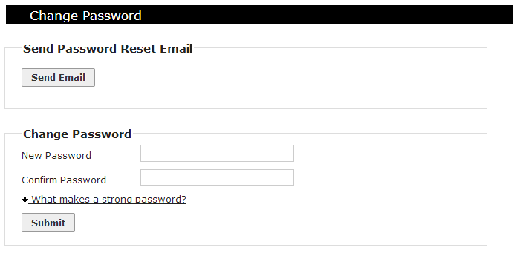

Passwords must be at least 8 characters long. For greater security, passwords should conform to the suggestions for strong passwords listed when the **What Makes a Strong Password?** link is clicked. Strong passwords are defined as being:

* At least 8 characters long
* Contains at least 3 of these 4 character types:
  + Upper-case letter
  + Lower-case letter
  + Number
  + Special character (!@#$%^&*)